**Welcome to Tic-Tac-Toe in R!**

This tutorial will guide you through how to play this Tic-Tac-Toe game.

This game relies on R and performs best when R is run through RStudio. R can be downloaded here: <https://www.r-project.org/> RStudio can be downloaded here: <https://www.rstudio.com/products/rstudio/download/>

**Getting started:**

To open the game, both the **TicTacToe_1of2** (R project file) and **TicTacToe_2of2** (R file) files need to be loaded. There are multiple ways to do this – I suggest first opening the **TicTacToe_1of2** file and then opening the **TicTacToe_2of2 file.**

RStudio is made up of 4 panels (source, console, environment, plotting). User inputs for this game occur completely within the RStudio source window (top-left) and the game outputs are viewed in the console and plotting windows.

Finally, this game relies on 2 R packages: *sp* and *rgeos*. If you are seeing error messages like

Error in library(sp) : there is no package called ‘sp’

it means these packages will need to be installed on your computer which can be done in RStudio under **Tools > Install packages.**

**Gameplay:**

**Setup:** In this version of Tic-Tac-Toe, you will be playing against a computer. The game is played by running through the lines of code sequentially in the source window, with occasional user inputs at certain lines.

To start, click on the beginning of the code in the source window and hit “Run” (can also do Ctrl+Enter on Windows or Command+Enter on Mac) until you reach line that says “#Set difficulty!”. You should be able to see the code executing in the console window and the game board appear in the plotting window as you are running the code. Now the game is setup and ready to go.

**1.** When you get to the “Set difficulty!” line, set the computer difficulty. Default difficulty is easy (Difficulty = “Easy”) but can be made more challenging by changing “Easy” to “Medium”, “Hard”, or “Impossible”. Continue running the code until you reach “#Player Move 1”.

**2.** When you reach “#Player Move 1”, tell the computer where you want your first X to be placed. This is done by making “Move_1” = a number from 1-9. The numbers correspond to places on the game board like so:

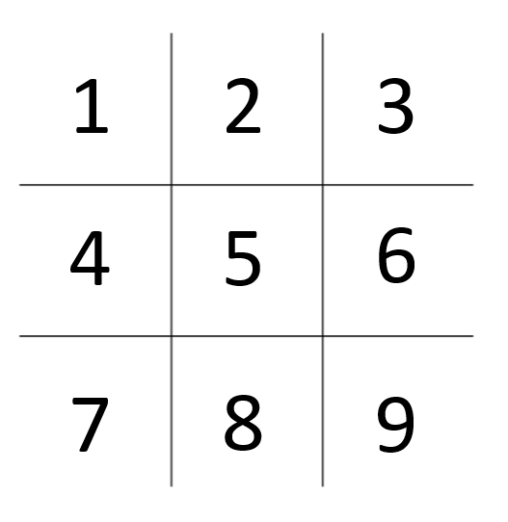

E.g. to place and X in the top-left corner, the line would be: Move_1 = 1.

Once Move_1 is defined, continue running the code to view your move on the board and the computer’s response.

**3.** Repeat step 2 with the subsequent player moves (Move_2, Move_3, Move_4) until the end of the game.

**4.** Once the game is over, you can play again by going to the beginning of the code and repeating steps 1-3.